Pass for level 14: Lg96M10TdfaPyVBkJdjymbllQ5L6qdl1

Step 1: Entering to natas 13

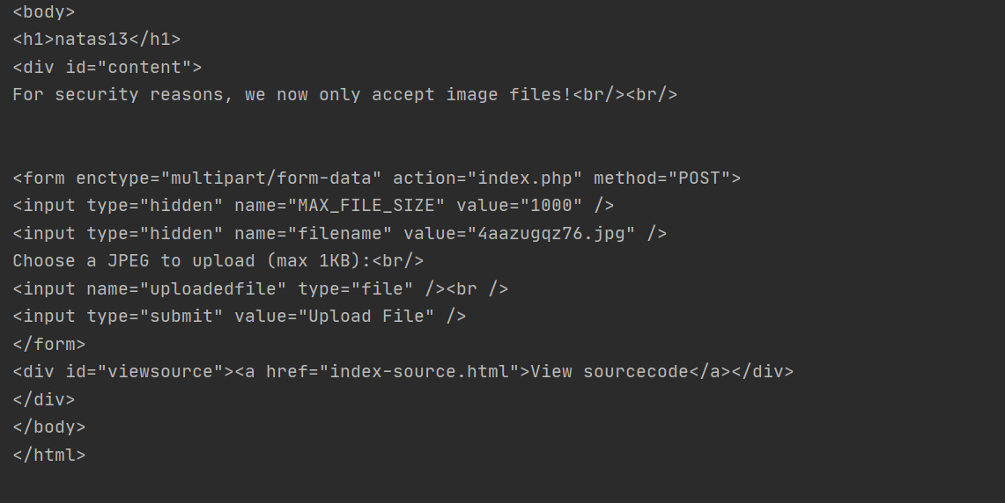

Now in a different from the previous level probably there is an php code that check weather is uploaded an image.

Step 2: Lets look at the source code in the /index-source.html extension.

And there is the difference in the codes :



So I looked for the function exif_imagetype()

And as I see in the document:



So now I know that there is a special header for all image that identify him.

Step 3: Signature for image

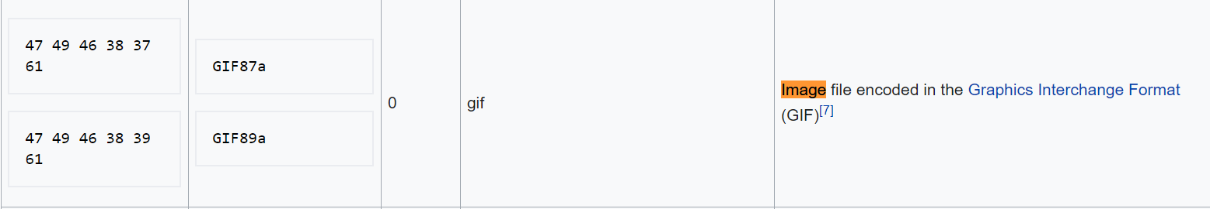

I used "file" command to see the format file of the Level12.php and see:



I added at the head of the file "GIF89a" and then I get:

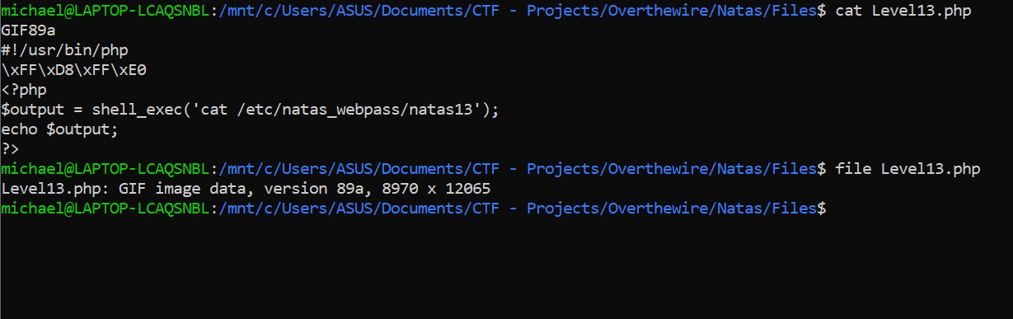

Step 4:Upload the file with requests post in python program



Step 5: Download the source code of the upload/ym1764iegt.php extension

